第一版-博幼字母檢測卷-Review 1-Aa~Oo

1. Connect the dots(連連看)，(每條線段D-F…各1分，共12分)

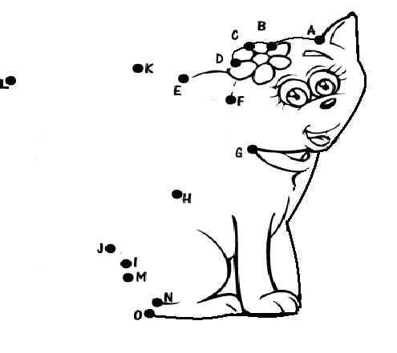

1. Listen and circle (圈圈看)，(每個2分，共20分)

**a** e h n I N

F J D O l m

G K E C b d

c j

班級： 姓名： 分數:

1. Switch (將大寫字母改為小寫字母，小寫字母改為大寫字母)

(一題3分，共27分)



|  |  |  |  |  |  |
| --- | --- | --- | --- | --- | --- |
|  | JAM |  |  | c**a**ll |  |
|  |  |
|  |  |

|  |  |  |  |  |  |
| --- | --- | --- | --- | --- | --- |
| 1. | BALL |  | 2. | CAKE |  |
|  |  |
|  |  |

|  |  |  |  |  |  |
| --- | --- | --- | --- | --- | --- |
| 3. | DOG |  | 4. | HAND |  |
|  |  |
|  |  |

|  |  |  |  |  |  |
| --- | --- | --- | --- | --- | --- |
| 5. | LION |  | 6. | l**a**ke |  |
|  |  |
|  |  |

|  |  |  |  |  |  |
| --- | --- | --- | --- | --- | --- |
| 7. | j**a**m |  | 8. | ink |  |
|  |  |
|  |  |

|  |  |  |
| --- | --- | --- |
| 9. | nail |  |
|  |
|  |

1. 依序寫下所聽到的大小寫字母(每個1分，共26分)

|  |  |  |  |  |  |  |  |
| --- | --- | --- | --- | --- | --- | --- | --- |
| 1. | 2. | 3. | 4. | 5. | 6. | 7. | 8. |
|  |  |  |  |  |  |  |  |
|  |  |  |  |  |  |  |
|  |  |  |  |  |  |  |  |

|  |  |  |  |  |  |
| --- | --- | --- | --- | --- | --- |
| 9. | 10. | 11. | 12. | 13. | 14. |
|  |  |  |  |  |  |
|  |  |  |  |  |  |
|  |  |  |  |  |  |

1. 請唸出下列字母(一個字母1分，共15分)

1. b d e i m 2.C K G J A 3.h l n m j