第一版-博幼字母檢測卷-Review2-Aa ~ Zz

1. Connect the dots(連連看)，(每條線段a-b…各0.5分，共12分)

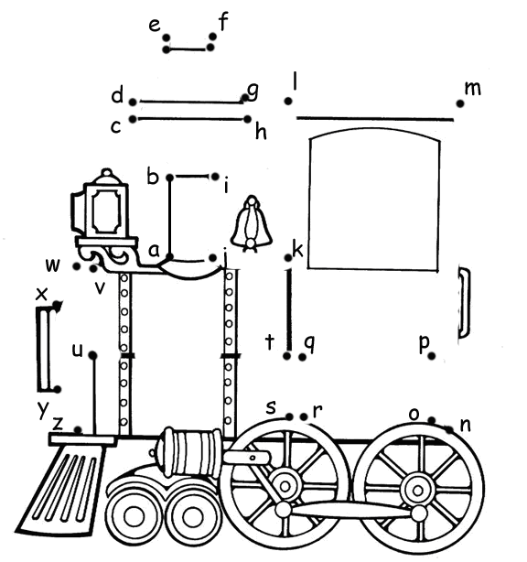

1. Listen and circle(將聽到的字母圈起來)，(每個2分，共20分)

E I O Q S C

F V G J d b

B P m n t d

p q

班級： 姓名： 分數:

1. Switch (將大寫字母改為小寫字母，小寫字母改為大寫字母)，

(一題3分，共27分)



|  |  |  |  |  |  |
| --- | --- | --- | --- | --- | --- |
|  | APPLE |  |  | c**a**ll |  |
|  |  |
|  |  |

|  |  |  |  |  |  |
| --- | --- | --- | --- | --- | --- |
| 1. | LITTLE |  | 2. | ZEBRA |  |
|  |  |
|  |  |

|  |  |  |  |  |  |
| --- | --- | --- | --- | --- | --- |
| 3. | YEAR |  | 4. | NOSE |  |
|  |  |
|  |  |

|  |  |  |  |  |  |
| --- | --- | --- | --- | --- | --- |
| 5. | POPE |  | 6. | under |  |
|  |  |
|  |  |

|  |  |  |  |  |  |
| --- | --- | --- | --- | --- | --- |
| 7. | RAIN |  | 8. | window |  |
|  |  |
|  |  |

|  |  |  |
| --- | --- | --- |
| 9. | QUEEN |  |
|  |
|  |

1. 依序寫下所聽到的大小寫字母(每個1分，共26分)

|  |  |  |  |  |  |  |  |
| --- | --- | --- | --- | --- | --- | --- | --- |
| 1. | 2. | 3. | 4. | 5. | 6. | 7. | 8. |
|  |  |  |  |  |  |  |  |
|  |  |  |  |  |  |  |
|  |  |  |  |  |  |  |  |

|  |  |  |  |  |  |
| --- | --- | --- | --- | --- | --- |
| 9. | 10. | 11. | 12. | 13. | 14. |
|  |  |  |  |  |  |
|  |  |  |  |  |  |
|  |  |  |  |  |  |

1. 請唸出下列字母(一個字母1分，共15分)

1. p q s c u 2. A K O Q T 3.b d e i h