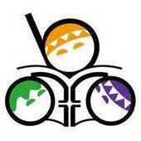 02博幼英文檢定-字母卷(自我檢定)

I. 1. C 2. m 3. y 4. E 5. O 6.T 7. B 8. K

9.Z 10.S

II. 1. sweet 2. PINK 3. love 4. LUNCH 5. bird 6.GREY

7. friend 8. KISS 9. zebra 10.SOCCER 11. actor 12.FACE

13. nurse 14.DRY 15. right

III. Bb, Cc, Dd, Ee, Ff, Gg, Hh, Ii, Jj, Kk, Ll, Mm, Nn, Oo, Pp, Qq, Rr, Ss,

Tt, Uu, Vv, Ww, Xx, Yy, Zz