國中英文閱讀檢測卷-V級(第一卷)
班級:__________ 姓名:___________ 分數:__________

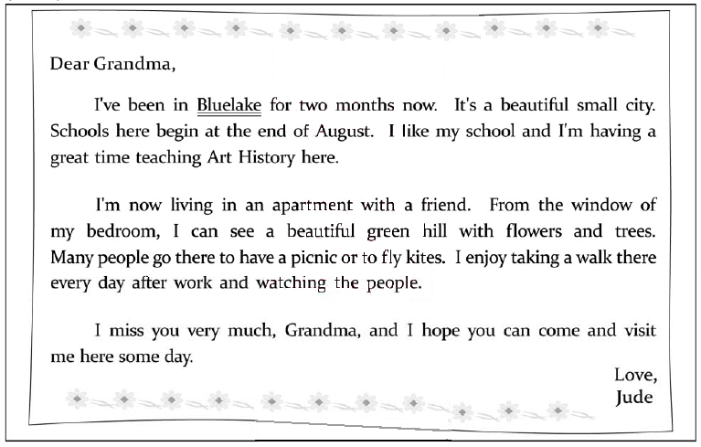
( ) | 1. | What does Jude do in Bluelake?
 |  | (A) Traveling.
 |  | (B) Studying.
 |  | (C) Playing.
 |  | (D) Working.
( ) | 2. | What is “Bluelake”?
 |  | (A) A country.
 |  | (B) A city.
 |  | (C) An art history museum.
 |  | (D) A school.
3. What does Jude like to do every day?(請用中文作答，意思對即可。)
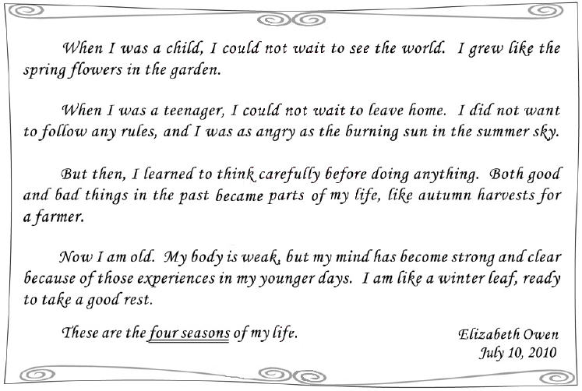

( ) | 1. | What does four seasons refer to in the reading?
 |  | (A) Four stages of life.
 |  | (B) Four parts of the year.
 |  | (C) Four parts of the body..
 |  | (D) Four kinds of weather.
( ) | 2. | Which is most likely true about the writer?
 |  | (A) She is wiser than before.
 |  | (B) She has a strong and healthy body.
 |  | (C) She enjoys growing flowers in her garden.
 |  | (D) She tries hard to forget what happened in the past.
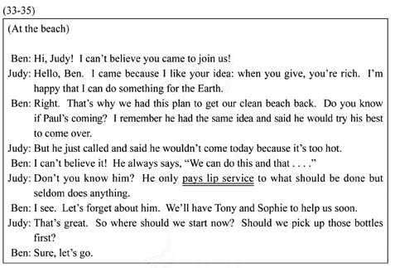
( ) | 1. | Which one is true?
 |  | (A) Paul comes to the beach in the end.
 |  | (B) Judy feels bad about going to the beach.
 |  | (C) Ben is surprised to see Judy at the beach.
 |  | (D)Tony and Sophie will not come to the beach.
( ) | 2. | What does Judy mean by saying Paul pays lip service?
 |  | (A) He enjoys eating.
 |  | (B) He is good at singing.
 |  | (C) He talks a lot but does little.
 |  | (D) He kisses people to show his thanks.
3. What do Judy and Ben do at the beach? (請用中文作答，意思對即可。)
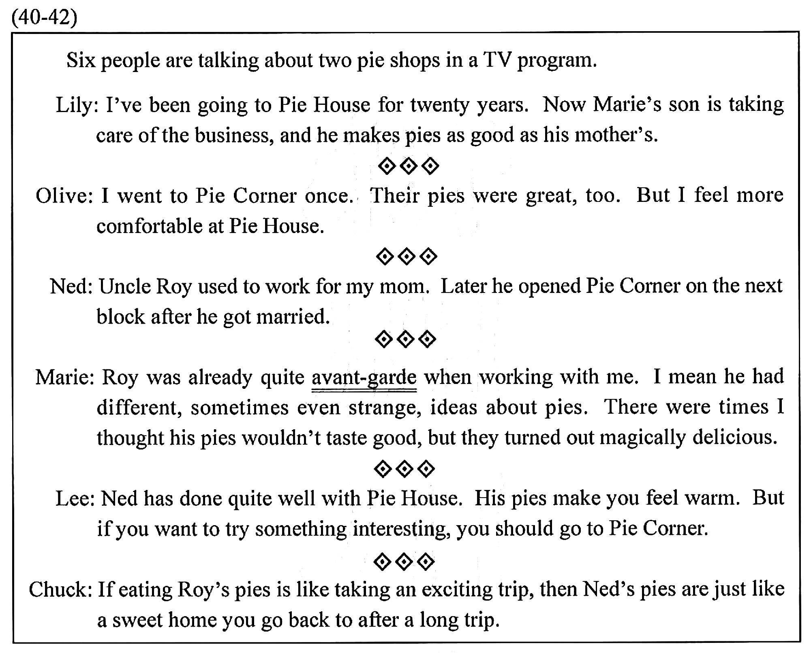
( ) | 1. | What do we know about the six people?
 |  | (A) They all have been to both pie shops
 |  | (B) They all talked about what the pies taste like.
 |  | (C) Some of them are the shopkeepers of the pie shops.
 |  | (D) Having many exciting and eye-opening life experiences.
( ) | 2. | What does avant-garde mean in the reading?
 |  | (A) Having a new and surprising way of thinking.
 |  | (B) Trying to find out where the problems come from.
 |  | (C) Trying to act like someone who knows everything.
 |  | (D) Having many exciting and eye-opening life experiences.
( ) | 3. | Which is true about the pie shops?
 |  | (A) Pie House is a family business.
 |  | (B) Pie Corner is next to Pie House.
 |  | (C) Pie Corner has a longer history than Pie House.
 |  | (D) Pie House gives people a place to stay for the night.

