國中英文閱讀檢測卷-III級(第一卷)
班級:__________ 姓名:___________ 分數:__________

Part A
John sells hot dogs outside the flower market. Sometimes people come up to him and ask for directions. Look at the map and answer the questions.
I.
Rose: Excuse me. Could you tell me how to get to the 1 ?
John: Of course. Just go down Market Road for two blocks and turn left. You’ll see a church. It’s next to the church, on First Street.
Rose: I see. Thanks.
John: You’re welcome.

II.
John: Good morning. Would you like a hot dog?
Fred: Yes, one please. By the way, where can I find a bookstore near here?
John: Go down Third Street and 2 . It’s between a shoe store and a music store.
Fred: Thank you.
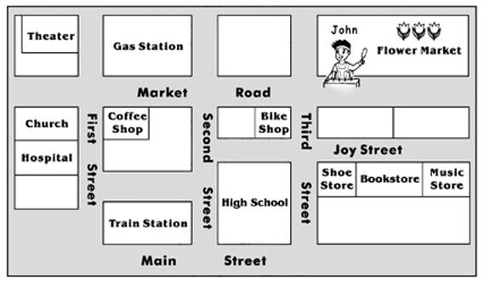

( ) | 1. | (A) theater
 |  | (B) hospital
 |  | (C) train station
 |  | (D) gas station
( ) | 2. | (A) turn to your right
 |  | (B) stop at the bike shop
 |  | (C) turn left on Joy Street
 |  | (D) walk past Main Street
Part B
As I was moving my scooter outside from the hallway, Mom called me from behind, “On your way back home, could you stop at a convenience store and buy a bottle of milk?” she asked. “I might have to go somewhere after the basketball game, but I will try my best to get one” I answered reluctantly. “Well, young man, you must buy a bottle, or we will have no milk tomorrow for our breakfast!” Mom said firmly.

scooter機車; hallway走廊; convenience store便利超商; somewhere某地方
reluctantly不甘願地；firmly堅定地
( ) | 1. | What did the Mom ask the young man to do?
 |  | (A) She asked him to play basketball.
 |  | (B) She asked him to buy breakfast from a convenience store.
 |  | (C) She asked him to buy milk for tomorrow’s breakfast.
 |  | (D) She asked him to buy milk together.
( ) | 2. | Why the mother asked the young man to buy a bottle of milk?
 |  | (A) The mom will cook with milk tomorrow.
 |  | (B) The mom doesn’t have money.
 |  | (C) They won’t have any milk for breakfast tomorrow.
 |  | (D) The mom is thirsty.
( ) | 3. | Which statement(陳述) is TRUE(真實的)?
 |  | (A) The young man didn’t want to help his mom, but he had to.
 |  | (B) Mom bought a bottle of milk on her way home.
 |  | (C) The young man was happy with his Mom’s request(要求).
 |  | (D) Mom wanted milk for today’s breakfast.
Part C
This book, “Dr. Jekyll and Mr. Hyde” was written by Robert Stevenson, the famous writer who wrote “Treasure Island,” in 1886. Dr. Jekyll is a well respected medical doctor. He is gentle and kind. But inside of him, there is a desire to do bad things. To let his desire come true, he successfully produces a medicine. After he drinks the medicine, he becomes an evil person. This person is named Mr. Hyde by himself. Even his appearance changes completely. Worst of all, he kills many women. Police begin to look into these killings. Dr. Jekyll has another medicine that changes Mr. Hyde back to the gentle and kind Dr. Jekyll. Unfortunately, the second medicine loses its function and Mr. Hyde dies. When he dies, it appears that he dies as Dr. Jekyll. This story tells us that every one of us has more than one personality. Some personalities are bad ones and we must never let them come out. Also, we must be careful in scientific research. We often get unexpected and dangerous results by doing scientific research.

respected受敬重的；medical藥學的；gentle有禮貌的desire慾望
produce製造；evil邪惡的；appearance外貌；completely完全的
unfortunately不幸的；function功能；personality個性；scientific科學的unexpected無法預料的；result結果

( ) | 1. | What’s the name of the medical doctor?
 |  | (A) Hyde
 |  | (B) Jekyll
 |  | (C) Robert
 |  | (D) We are not sure.
( ) | 2. | Why did the evil person die in the end?
 |  | (A) He was killed by the police man.
 |  | (B) The medicine didn’t work after he drank it.
 |  | (C) He was killed by the medical doctor.
 |  | (D) He took too much medicine.
( ) | 3. | Which statement(陳述) is TRUE(真實的)?
 |  | (A) We must let our personalities come out no matter good or bad.
 |  | (B) If we don’t do science research carefully, the result will be dangerous or unexpected.
 |  | (C) The doctor was evil at beginning but changed his personalities after drank the medicine.
 |  | (D) The doctor didn’t live the personalities with evil one.
Part D

Q: Why did the man keep taking off the soda's bottle cap and putting it back on?
A: Because it said, "Sorry, try again."

( ) | 1. | What does the joke imply(暗示)?
 |  | (A) We have to drink soda immediate after we open its bottle cap.
 |  | (B) The soda doesn’t have a cap.
 |  | (C) The soda is not good for health.
 |  | (D) Recommend(建議) customers to buy another soda to win the prize or something next time.

