國中英文閱讀檢測卷-IV級
班級:__________ 姓名:___________ 分數:__________

Here is a map and a train schedule from West Town to South End.
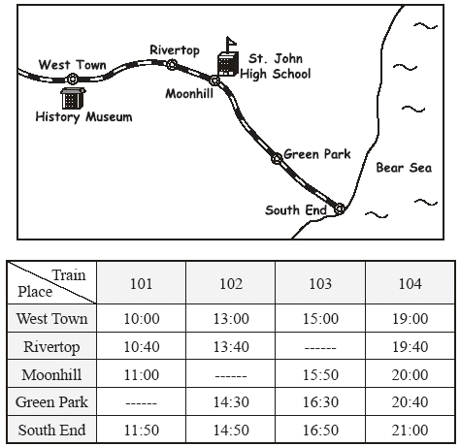 schedule時刻表

( A ) | 1. | Mandy lives in West Town. She will go to Moonhill with her  friends tomorrow morning. Which train should she take?
 |  | (A) 101
 |  | (B) 102
 |  | (C) 103
( B ) | 2. | John’s grandmother lives in Green Park, and he lives in Rivertop. Their family usually visits her grandmother on Saturday afternoon. They will visit her again. Which train should they take?
 |  | (A) 101
 |  | (B) 102
 |  | (C) 104
Mr. Scrooge is only interested in making money. He is stingy. When some people come to ask him to give money to the poor, he refuses. One day, when he comes back home to sleep, he sees several ghosts. The first ghost is Mr. Marley who is dead. Mr. Marley was a partner of Mr. Scrooge and a miser too. The ghost of Marley tells Mr. Scrooge that he suffers a lot after he dies because of selfishness Then Mr. Scrooge is visited by several ghosts. One brings him to visit Mr. Cratchit’s family. Mr.Cratchit is his staff, but he was paid little salary by Mr. Scrooge Over there, there is a celebration of Christmas and the little kid, Tiny Tim, is very ill and the family has no money to send him to a doctor. Still, Mr. Cratchit asks the family to wish Mr. Scrooge live a happy life. Finally, Mr. Scrooge is shown how miserable he will be if he dies as a miser, and how happy he will be if he is generous.
generous 慷慨；ghosts 鬼魂；ill生病；kid 小孩；miser 小氣的人, 自私的人；miserable 悲慘；partner 伙伴；refuse 拒絕；salary 薪水；staff員工
space空間；selfishness自私；the poor窮人；tiny小；visit 訪問
( C ) | 1. | Which statement is FALSE(錯誤)?
 |  | (A) Mr. Marley was a miser when he was alive.
 |  | (B) Mr. Scrooge never helps the poor before he met the ghosts.
 |  | (C) Mr. Cratchit hates what Mr. Scrooge has done to him.
( B ) | 2. | What does “stingy”mean?
 |  | (A) Be generous to every people.
 |  | (B) Be very selfish and not willing to help the poor.
 |  | (C) Be miserable.
3. Why does Mr. Cratchit have no money to send his son to a doctor? (請用中文回答，意思答對即可。)
因為他的薪水很少，無法支付醫藥費。
Ian doesn’t usually dream during sleep, but he dreamed of my cat, Inky last night. In his dream, a pink Hello Kitty, the Japanese comic icon, was trying to be friend with our Inky. Inky looked afraid, yet he was curious about Hello Kitty. Suddenly, Ian was awakening by a sound of a cat. To his surprise, Inky was standing right in front of him. On his right, there was another striped and fluffy cute little kitten that was not Hello Kitty.
After his parents saw the kitten, they said firmly “one is enough.” He thought they would be happy to see the kitten, but they look rather upset. He borrowed my digital camera and took some pictures of the kitten. Later, he posted them on the internet and hope someone would adopt it. A few days later, he received several messages both from local and abroad. He decided to interview some of people and make a decision.
dream of 夢到；icon 圖像; be curious about好奇; awaken 驚醒; surprise驚奇; striped條紋的; upset懊惱的; digital camera數位相機; adopt領養; receive收到; local本地的; abroad國外

( B ) | 1. | What did Ian do to help the kitten?
 |  | (A) He made his parent keep two cats.
 |  | (B) He tried to find someone who would adopt it.
 |  | (C) He took some pictures for the cat.
( A ) | 2. | How did Inky feel about “Hello Kitty” in Ian’s dream?
 |  | (A) It was curious.
 |  | (B) It was happy.
 |  | (C) It was upset.
3. Who found the little kitten probably?
(請用英文或中文作答，意思對即可。)
Inky.
Parker: I'm in a big trouble!
Susan: Why is that?
Parker: I saw a mouse in my house!
Susan: Oh, well, all you need to do is use a trap.
Parker: I don't have one.
Susan: Well then, buy one.
Parker: Can't afford one.
Susan: I can give you mine if you want.
Parker: That sounds good.
Susan: All you need to do is just use some cheese in order to make the mouse come to
the trap.
Parker: I don't have any cheese.
Susan: Okay then, take a piece of bread and put a bit of oil in it and put it in the trap.
Parker: I don't have oil.
Susan: Well, then put only a small piece of bread.
Parker: I don't have bread.
Susan: Then what is the mouse doing at your house?!

afford 負擔; trap 捕鼠器

( A ) | 1. | What does “mine” refer to?
 |  | (A) my trap
 |  | (B) my cheese
 |  | (C) my bread
( C ) | 2. | What has Susan suggested to catch the mouse?
 |  | (A) Kill the mouse.
 |  | (B) Use one’s hands to catch the mouse.
 |  | (C) Use some cheese to make the mouse come to the trap.
( A ) | 3. | Which statement is TRUE?
 |  | (A) Parker had nothing to catch the mouse in his house.
 |  | (B) Susan would lend some oil to Parker.
 |  | (C) Susan found a mouse at her house.

